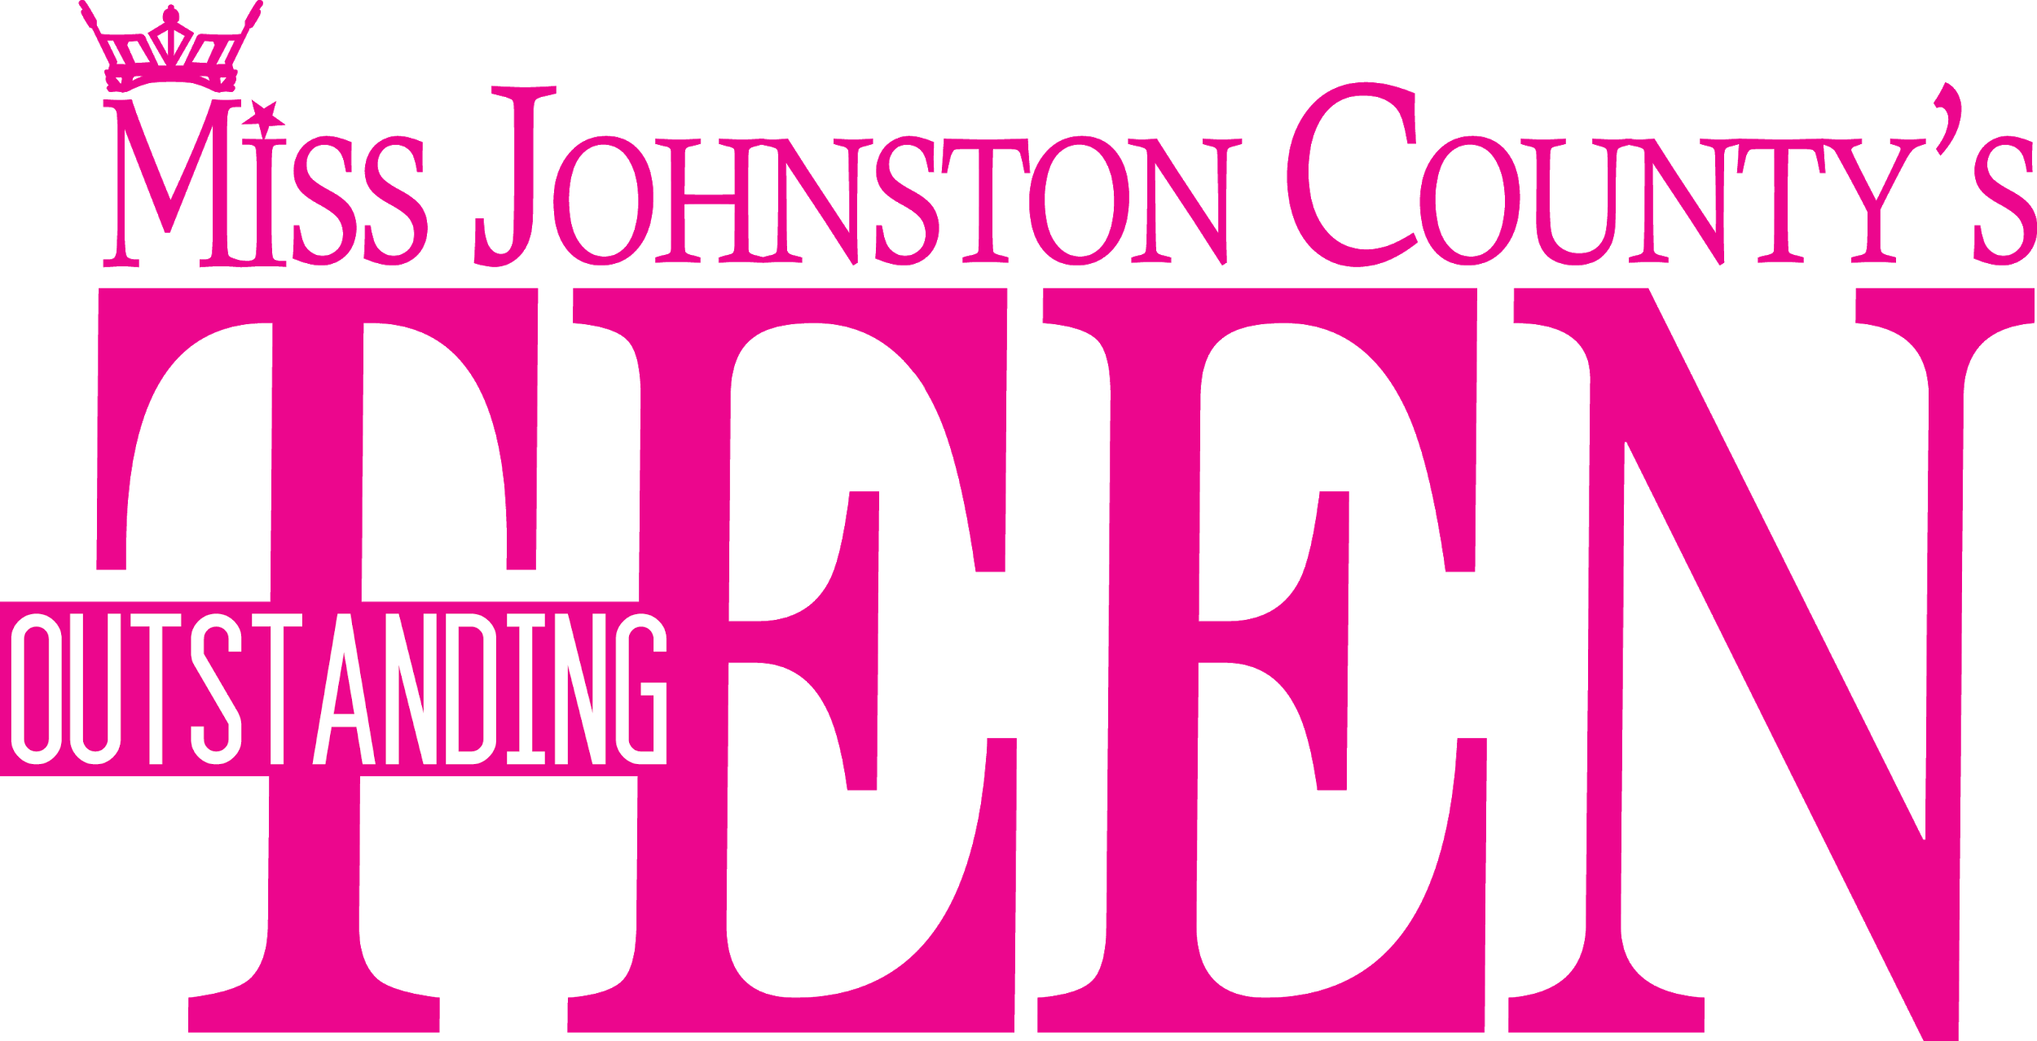
Miss Johnston County & Miss Cleveland Outstanding Teen
INTENT FORM

January 18, 2020 6 pm

Name: ________________________________________________________________

Home Address____________________________________________________________
Home Phone Number: ___________________________________________________

Cell Phone Number:_____________________________________________________
Email Address:_______________________________________________________

Talent:______________________________________________________________

Age:_________ School Status: ______________________________________

Previous Pageant(s): _____________________________________________________
This form signifies your commitment to the pageant. Please return completed form to:

Miss Johnston County Scholarship Organization
7465 Meadowbrook Rd
Benson, NC 27504
OR Email to info@missjoco.org

Outstanding Teen Contestants please submit $175 entry fee
along with your intent form.

