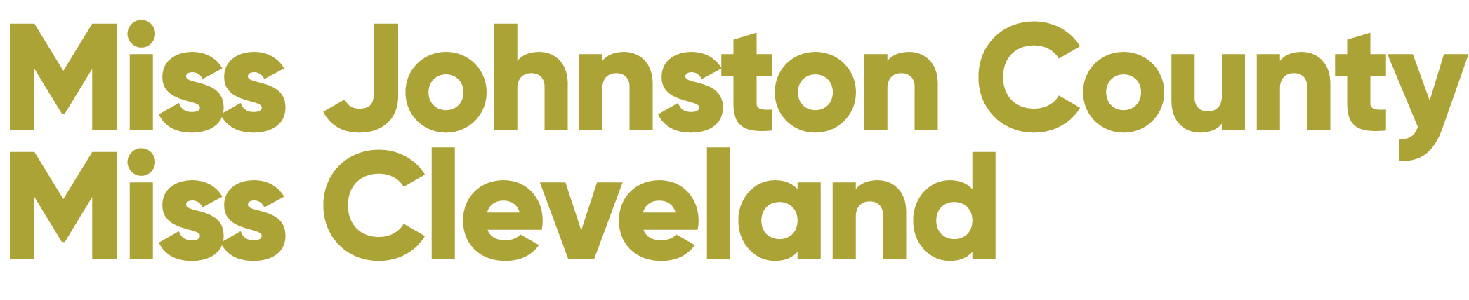

Carolina Princess Information

Congratulations! You have been selected to take part in the prestigious 2022 Miss Johnston County & Miss Cleveland Scholarship Competition. The 2022 competition will be held at Cleveland High School on January 15, 2022 at 6 pm.

The Carolina Princess Program is established for young ladies ranging in age from 6-12. It is a mentoring program in which the Carolina Princesses are mentored by their Miss or Outstanding Teen contestants. The Carolina Princess is encouraged to join her mentor in as many appearances, volunteer opportunities and other events as possible throughout the year.

Each Johnston County/Miss Cleveland Carolina Princess is required to attend the Miss North Carolina competition in June 2022.

Carolina Princesses are required to submit an application and a $75 fee to participate in our program. You can find our application in our paperwork section, please submit the $75 fee (cash/check) at our paperwork meeting. Each candidate is REQUIRED to have a Carolina Princess to compete.

Following is more information about our 2022 Carolina Princess competitions

FUNDRAISER: Each Carolina Princess will be responsible for creating signature boards. Using a standard poster board, and your own creative freedom, each girl should prepare a signature board for your family and friends. The cost is $1 per signature. The princess who sells the most signatures will receive a special award. The proceeds from the board will benefit the Children’s Miracle Network and the Miss Johnston County/Miss Cleveland Scholarship award

PRINCESS SHOWCASE - We will host a Princess Showcase at 2 pm on January 15, 2022 in the auditorium at Cleveland High School. Each princess is asked to participate, they will be performing their opening number production and they have the chance to perform their own individual talents, however it is not required. We will recognize each Carolina Princess on stage during the program and all princesses will receive gift bags for their participation. Admission to the Showcase is $10 - no tickets will be sold in advance. The Carolina Princesses will also perform their opening number and participate in the production finale during the pageant at 6 pm.

PAPERWORK DEADLINES - Paperwork will be accepted for Carolina Princesses on December 11 at Cleveland High School at 10 am. Please bring completed paperwork and $75 fee at this date.

PRODUCTION REHEARSALS: January 8, 2021 - MANDATORY Rehearsal ALL Candidates and Carolina Princesses at Alicia’s School of Performing Arts, Benson
  - 9:00 - 10:30 - Carolina Princess Rehearsal ONLY
  - 10:30 - 12:00 - All Candidates plus Carolina Princess - rehearse Finale
  - 12:00 - Carolina Princesses Depart
  - 12:00 - 3:30 - Miss & Teen Candidates ONLY

DRESS REHEARSALS: January 14, 2020 at 5:30 Dress Rehearsal at Cleveland High School. ALL Candidates and Carolina Princesses - We will rehearse our finale first so that we can get our Carolina Princesses on their way to a great night’s sleep!

WARDROBE: We will announce the requirements for the Carolina Princess Production and Finale at our Paperwork Meeting on December 11, 2021.

We look forward to having you participate in our competition.

CP NAME_____________________________________________________

Miss/Teen Contestant Name _______________________________________

Parent’s Cell # _________________________ Home #___________________
Parent’s email __________________________________________________

Mother’s Name ________________________Father’s Name _______________
Address _____________________________CITY ______________________
Birthdate ____________________________Age _______________________

Performing Talent at Showcase: Yes _________ No ________

If Yes, Talent being Performed: _______________________________________

Achievements & Community Involvement: ______________________________
_____________________________________________________________
_____________________________________________________________
________________________________________________________________________________________________________________________________________________________________________________________________

Signed ____________________________________Date ___________________

Please submit this signed application and the $75 registration fee by December 11, 2021. A Carolina Princess may not participate until this paperwork and payment has been received.

Johnston County/Miss Cleveland Carolina Princesses are encouraged to sell at least one half page for the program book. Listed below are the prices for camera ready advertisements.

FULL PAGE: $150
HALF PAGE: $75
QUARTER PAGE: $50
BUSINESS CARD: $25

ALL CHECKS MUST BE PAYABLE TO THE JOHNSTON COUNTY SCHOLARSHIP ORGANIZATION WHICH IS A NON-PROFIT ORGANIZATION.

All AD pages must be emailed to us by January 1, 2022 and paid in full by January 8, 2022 (Our production rehearsal) (NO EXCEPTIONS). ADs can be emailed to info@missjoco.org. Ads must be printer ready.
Full pages are 8.5 x 11
No photos of ads will be accepted - must be original
Please label ad info with candidate name in the email.

PRINCESS NAME:__________________________________________________
TEEN OR MISS DIVISION____________________________________________

Name of Business Ad Size Amount Paid

